**Descriptif**

|  |  |  |  |  |  |
| --- | --- | --- | --- | --- | --- |
| **Descriptive Statistics** | | | | | |
|  | N | Minimum | Maximum | Mean | Std. Deviation |
| CR | 32 | .38 | .75 | .5257 | .10094 |
| DER | 32 | 1.55 | 3.93 | 2.6008 | .62506 |
| Harga_Saham | 32 | 2027.00 | 7083.00 | 4911.6562 | 1364.07408 |
| Valid N (listwise) | 32 |  |  |  |  |

**Pengaruh *Current Ratio* Terhadap Harga Saham PT Indosat, Tbk**

|  |  |  |  |  |
| --- | --- | --- | --- | --- |
| **Model Summary** | | | | |
| Model | R | R Square | Adjusted R Square | Std. Error of the Estimate |
| 1 | .395a | .156 | .128 | .28380 |
| a. Predictors: (Constant), CR | | | | |

|  |  |  |  |  |  |  |
| --- | --- | --- | --- | --- | --- | --- |
| **ANOVAa** | | | | | | |
| Model | | Sum of Squares | df | Mean Square | F | Sig. |
| 1 | Regression | .446 | 1 | .446 | 5.540 | .025b |
| Residual | 2.416 | 30 | .081 |  |  |
| Total | 2.863 | 31 |  |  |  |
| a. Dependent Variable: Harga_Saham | | | | | | |
| b. Predictors: (Constant), CR | | | | | | |

|  |  |  |  |  |  |  |
| --- | --- | --- | --- | --- | --- | --- |
| **Coefficientsa** | | | | | | |
| Model | | Unstandardized Coefficients | | Standardized Coefficients | t | Sig. |
| B | Std. Error | Beta |
| 1 | (Constant) | 7.833 | .270 |  | 28.990 | .000 |
| CR | 1.189 | .505 | .395 | 2.354 | .025 |
| a. Dependent Variable: Harga_Saham | | | | | | |

**Pengaruh *Debt to Equity Ratio* Terhadap Harga Saham PT Indosat, Tbk**

|  |  |  |  |  |
| --- | --- | --- | --- | --- |
| **Model Summary** | | | | |
| Model | R | R Square | Adjusted R Square | Std. Error of the Estimate |
| 1 | .670a | .449 | .431 | .22921 |
| a. Predictors: (Constant), DER | | | | |

|  |  |  |  |  |  |  |
| --- | --- | --- | --- | --- | --- | --- |
| **ANOVAa** | | | | | | |
| Model | | Sum of Squares | df | Mean Square | F | Sig. |
| 1 | Regression | 1.286 | 1 | 1.286 | 24.484 | .000b |
| Residual | 1.576 | 30 | .053 |  |  |
| Total | 2.863 | 31 |  |  |  |
| a. Dependent Variable: Harga_Saham | | | | | | |
| b. Predictors: (Constant), DER | | | | | | |

|  |  |  |  |  |  |  |
| --- | --- | --- | --- | --- | --- | --- |
| **Coefficientsa** | | | | | | |
| Model | | Unstandardized Coefficients | | Standardized Coefficients | t | Sig. |
| B | Std. Error | Beta |
| 1 | (Constant) | 9.305 | .176 |  | 52.864 | .000 |
| DER | -.326 | .066 | -.670 | -4.948 | .000 |
| a. Dependent Variable: Harga_Saham | | | | | | |

**Pengaruh *Current Ratio* dan *Debt to Equity Ratio* Terhadap**

**Harga Saham PT Indosat, Tbk**

|  |  |  |  |  |  |
| --- | --- | --- | --- | --- | --- |
| **Model Summaryb** | | | | | |
| Model | R | R Square | Adjusted R Square | Std. Error of the Estimate | Durbin-Watson |
| 1 | .671a | .451 | .413 | .23285 | .702 |
| a. Predictors: (Constant), DER, CR | | | | | |
| b. Dependent Variable: Harga_Saham | | | | | |

|  |  |  |  |  |  |  |
| --- | --- | --- | --- | --- | --- | --- |
| **ANOVAa** | | | | | | |
| Model | | Sum of Squares | df | Mean Square | F | Sig. |
| 1 | Regression | 1.290 | 2 | .645 | 11.898 | .000b |
| Residual | 1.572 | 29 | .054 |  |  |
| Total | 2.863 | 31 |  |  |  |
| a. Dependent Variable: Harga_Saham | | | | | | |
| b. Predictors: (Constant), DER, CR | | | | | | |

|  |  |  |  |  |  |  |  |  |
| --- | --- | --- | --- | --- | --- | --- | --- | --- |
| **Coefficientsa** | | | | | | | | |
| Model | | Unstandardized Coefficients | | Standardized Coefficients | t | Sig. | Collinearity Statistics | |
| B | Std. Error | Beta | Tolerance | VIF |
| 1 | (Constant) | 9.207 | .413 |  | 22.305 | .000 |  |  |
| CR | .131 | .493 | .044 | .266 | .002 | .705 | 1.419 |
| DER | -.314 | .080 | -.647 | -3.945 | .000 | .705 | 1.419 |
| a. Dependent Variable: Harga_Saham | | | | | | | | |

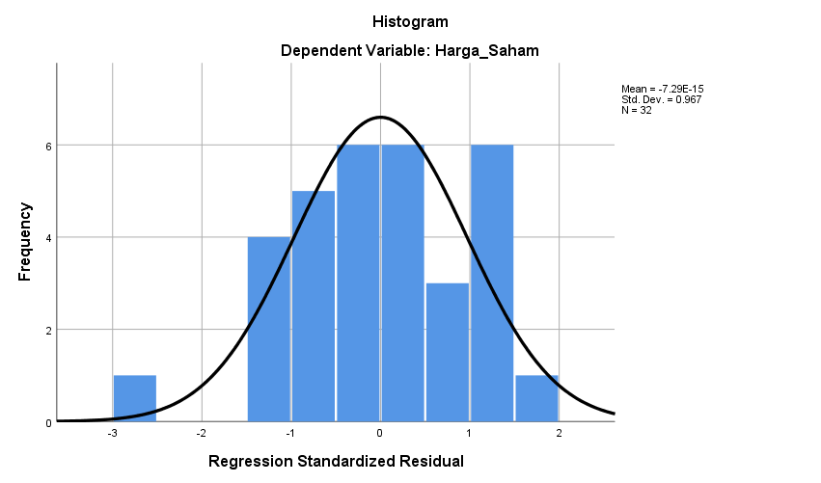

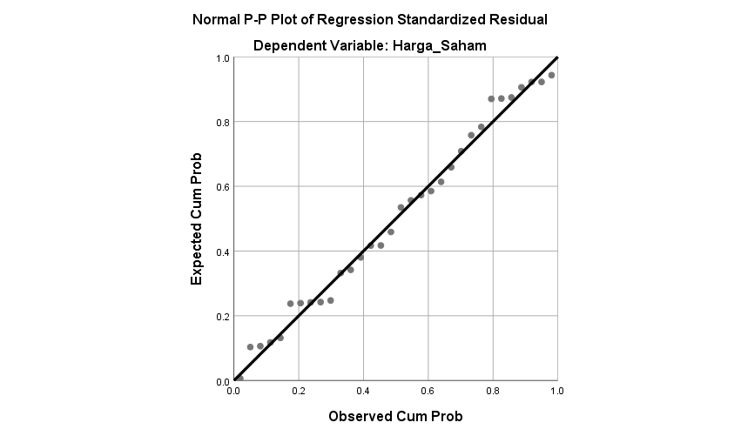

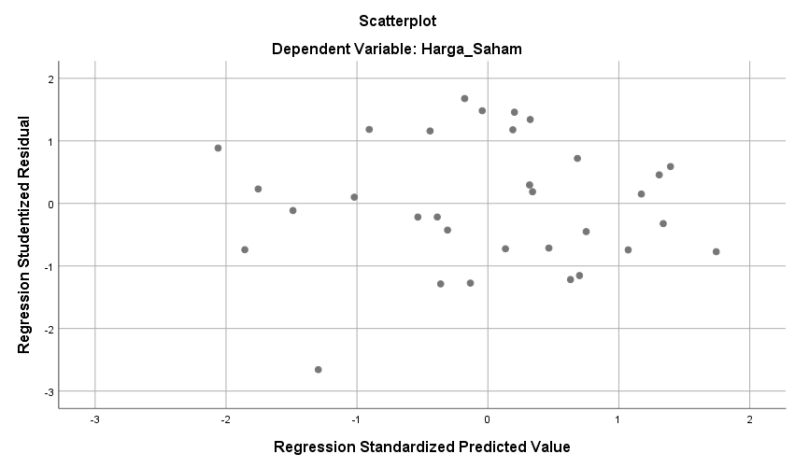

**NPar Tests**

|  |  |  |
| --- | --- | --- |
| **One-Sample Kolmogorov-Smirnov Test** | | |
|  | | Unstandardized Residual |
| N | | 32 |
| Normal Parametersa,b | Mean | .0000000 |
| Std. Deviation | .22521269 |
| Most Extreme Differences | Absolute | .097 |
| Positive | .072 |
| Negative | -.097 |
| Test Statistic | | .097 |
| Asymp. Sig. (2-tailed) | | .200c,d |
| a. Test distribution is Normal. | | |
| b. Calculated from data. | | |
| c. Lilliefors Significance Correction. | | |
| d. This is a lower bound of the true significance. | | |